ICT Project Management Framework

Document title | ICT Project Management Framework
Contact details | Department of Corporate and Digital Development
Approved by
Date approved
Document review
TRM number | NA

Version | Date | Author | Changes made
0.1 | 17 February 2021 | EPS Governance | Initial draft
0.2 | 19 February 2021 | EPS Governance | Review and updates
0.3 | 26 February 2021 | EPS Leadership | Updates
1.0 | 11 March 2021 | EPS Governance | Final draft

Reviewers Name | Role
Grace Waugh | Director Governance, EPS
Bronwyn Lo | Program Director, EPS
Paul Gooding | Senior Director, EPS

Approvers Name | Role | Signature | Date
Kathleen Robinson | Chief Executive Officer, DCDD
Chris Hosking | Deputy Chief Executive Officer, DCDD

Acronyms | Full form
NTG | Northern Territory Government
DCDD | Department of Corporate and Digital Development
ICT | Information and Communications Technology
PMF | Project Management Framework
PMO | Program Management Office / Project Management Office
SGR | Stage Gate Reviews
PRINCE2 | Projects IN Controlled Environments

Contents
1. Purpose 4
2. Definitions 4
3. Authority 4
4. ICT Project Management Framework (PMF) 5
4.1. PMF overview 5
4.2. Lifecycles 5
4.2.1. NTG ICT investment lifecycle 5
4.2.2. Project management lifecycle 5
4.2.3. Project stages 6
4.2.4. Project management elements 6
4.2.5. Project management factsheets 6
5. Governance 7
5.1. ICT governance 7
5.2. Project governance 7
5.3. Roles and responsibilities 7
6. Reporting 8
6.1. Project reporting 8
6.2. Project registers 8
7. Stage gate reviews 8
8. Information management 8
9. Feedback and maintenance 9

Purpose
The PMF outlines a standard approach to guide the conduct of projects in the NTG.
The PMF is based on the PRINCE2® project management methodology which provides a consistent approach to the management of projects that is industry standard and professionally recognised. The methodology can be applied regardless of project scale, type, organisation, geography or culture.

Definitions
A project is a temporary structure that is created for the purpose of delivering one or more business products according to an agreed business case.
A program is a temporary, flexible organisation structure created to coordinate, direct and oversee the implementation of a set of related projects and activities in order to deliver outcomes and benefits related to the organisations strategic objectives.
Project management is the planning, delegating, monitoring and control of all aspects of the project, and the motivation of those involved to achieve the project objectives within the expected performance targets for time, cost, quality, scope, benefits and risks.

Authority
The PMF is to be referenced within the following authorities:
- Treasurer’s Directions – ICT Governance series
- Northern Territory Government ICT Governance Framework
- NT legislation (Financial Management Act 1995, Procurement Act 1995)

ICT Project Management Framework (PMF)

PMF overview
The PMF has been developed to provide structure and guidance necessary for a controlled and consistent approach to effectively manage projects and programs in the Northern Territory Government (NTG). The PMF can be applied to all projects and programs.
The PMF is comprised of: lifecycle stages, activities, deliverables, governance, roles and responsibilities, and reviews. The PMF refers to best practice Project Management Elements and Factsheets.
The figure below provides an overview of the PMF:
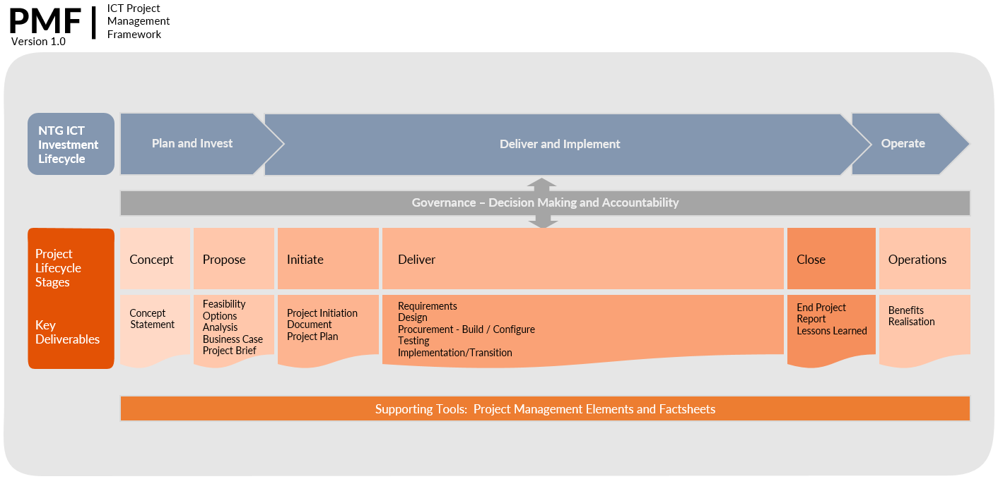

Lifecycles

NTG ICT investment lifecycle
The ICT investment lifecycle outlines a process by which agencies plan, propose and deliver ICT investments, projects and programs in the NTG. The purpose of the investment lifecycle is to ensure there is a sound investment proposal (business case) and that government investments deliver their intended benefits.
Good project management is fundamental to the success of the investment.

Project management lifecycle
The PMF lifecycle aligns with the NTG ICT investment as illustrated in the lifecycle diagram above.
The PMF uses the project management lifecycle process to direct and control all activities of a project from initial concept through to close and into operations. The PMF lifecycle is separated into distinct stages and multiple phases. Project stages may overlap or progress concurrently and a project may move back and forth between stages. This situation could occur where stage gate reviews are being conducted while some delivery work is continuing.

Project stages
The PMF consists of the following project stages:
- concept
- propose
- initiate
- deliver
- close.

Project management elements
The following project management elements provide a high level summary of the key project activities and outputs.
- scope management
- benefits realisation management
- change control management
- issue management
- risk management
- project reporting
- quality management
- schedule management.

Project management factsheets
The following project management factsheets detail essential information and key activities required for effective project management delivery.
- Business Case
- Project Initiation Document.

Governance
Governance is the structure for making decisions and provides oversight to the entire project. Governance provides a single point of accountability and when done effectively, underpins project success, resulting in efficient and timely decision making.

ICT governance
“The NTG ICT Governance Framework provides the foundation for the effective management of ICT across government. The Framework ensures ICT is aligned ICT with government’s strategic direction; consistent and appropriate standards are applied across government; major ICT investments are tested and ICT projects are monitored through to solution delivery.”
Treasurers Directions Information and Communications Technology, Section ICT1.1: Governance – Overview
The Framework, Treasurer’s Directions ICT series, ICT policies, standards and guidelines and agency governance models matrix together provide an integrated package for the management of ICT across government.

Project governance
Project governance is required to ensure the project is delivering its intended objectives and achieving the anticipated outcomes and benefits. The project governance structure must be appropriate to the size and complexity of the project. The following governing bodies are common to project governance structures:
- Program Steering Committee role is to provide program oversight, make recommendations for critical decisions, and advise the Program Owner and Program Sponsor. The committee’s role is defined by its Terms of Reference, which are jointly approved by the Program Owner and the Program Sponsor.
- Project Board is responsible for providing the operational direction of the project and supporting the Project Manager with the necessary decisions and issue resolution to enable the project to proceed.

Roles and responsibilities
There are essential roles in Project Management that ensure the success of project delivery.
- Program / Project Sponsor is appointed by the agency Chief Executive to provide oversight to the program and ensures the overall program objectives are met.
- Program / Project Director is primarily operational and includes being responsible for planning, governance and overseeing the successful delivery of the program’s output/products.
- Program / Project Owner (Business Owner) is the client agency and is accountable for ensuring the stated benefits of the program to the business are achieved. The Program Owner will approve the plans and provide authorisation to move forward with each stage of the program/project.
- Business User (Senior User) is responsible for specifying the needs of those who will use the project’s products; user liaison with the Project Team; and monitoring to ensure that the solution will meet user needs within the parameters specified in the project’s Business Case in terms of quality, functionality and usability.
- Supplier (Senior Supplier) represents the interests of those designing, developing, facilitating, procuring and implementing the project’s products. This role is accountable for the quality of products delivered by the supplier(s) and is responsible for the technical integrity of the project. The Supplier can be an internal or external resource.
- Project Manager has the authority to run the project on a day to day basis on behalf of the Project Board within the constraints laid down by the Board.
- Business Change provides a representative from the business to manage the realisation of benefits through the integration of new capability within the business practices.

Reporting

Project reporting
Project reporting monitors project progress according to project plans. It ensures that all stakeholders are advised of project performance and enables project stakeholders to make informed decisions. Reporting occurs at multiple levels and multiple points within a project.
A Project Reporting Element has been developed as a part of this framework and provides details of the key information required for effective project reporting.

Project registers
Project Registers are central source documents that provide information on projects. Project Registers are a mechanism for maintaining traceability of various activities and decisions made during the course of project.
There are different types of project registers that are established and maintained throughout the project lifecycle

Stage gate reviews
Stage gate reviews are performed at critical points of a project and examine key decision points to check that an ICT project is on track and will deliver the expected results within the set timeframes and on budget.
Stage gate reviews provide the agency with an independent assessment on the progress of a project which helps to ensure that the project is on track and can progress to the next stage of development or implementation. The stage gate review will assist with determining whether the project should continue unchanged, continue with changes or cease.

Information management
A standard management approach for creating, managing, storing and using program and project information must be established and maintained.
All programs and projects must adhere to the NT Information Act 2002.

Feedback and maintenance
Maintenance of the PMF is the responsibility of DCDD.
The reference material referred to in the PMF can be found on the DCDD Internet.

